REPORT OF THE TOWN GOVERNANCE COMMITTEE
FEBRUARY 22, 2022

TABLE OF CONTENTS CONTENTS

I. Executive Summary
II. Committee Composition
III. Scope and Methodology of Review
IV. Research Findings
V. Survey Findings
VI. Recommendations

ATTACHMENTS
- Town Charter
- Invitation to Participate
- Sample of Survey
- Survey Design and Distribution
- Meeting Minutes
- Alternative Forms of Town Government

- EXECUTIVE SUMMARY
On April 27, 2021 the Board of Selectmen (“Board”) established an ad hoc committee of the board to review the Town’s form of government (“Committee”) and make recommendations to the Board before the 2022 Town Meeting. The Town’s form of government was last reviewed in 2002.
- Investigate alternatives to the current Town Meeting form of government
- Make sure the Town is meeting its constitutional requirement to provide adequate access to voting
- Make a formal report and recommendations to the Town no later than the March 2022 Town Meeting

The Committee recognized that the Bow Town Charter has been unaltered since 1727 (See: ATTACHMENT A) and recommends the Board establish a committee charged with educating the citizens of Bow on the pros and cons of amending the Town Charter to adjust our form of government to better meet the needs of our growing community into the future.

- COMMITTEE COMPOSITION
The Committee was open to all who volunteered to serve and were appointed by the Select Board. The Committee was originally comprised of Angela Brennan, Margaret Byrnes, Harry Judd, Jeffrey Levesque, Sue Marcotte-Jenkins, Andrew Mattiace, and Joyce Prowse. Ms. Byrnes resigned due to conflicting obligations and Mr. Levesque resigned because he moved from Bow. The Committee represented a cross section of Bow, with the age of members ranging from millennials to septuagenarians and the range of time living in Bow being from over 30 years to one year. The homes of the members were also geographically diverse.

- SCOPE OF REVIEW
The Committee began its work with personal and anecdotal insights into the challenges citizens have with participating in our present form of government, as reflected in a vocal minority introducing warrants to adopt the so-called “SB-2” form of government 9 times in the past 22 years. While those efforts were overwhelming rejected by voters, the reasons behind the desire for change are worthy of study and understanding. The Committee was mindful of the appropriateness of looking beyond the present when considering how best to encourage citizen participation and sense of responsibility in our community.
The Committee conducted meetings that were published and open to public participation. The Committee members divided research responsibilities and worked independently for many hours and met to review the status of that research. Early on, The Committee read the report of another town government study committee that convened 20 years ago. That was the last time Bow’s government was studied in depth. We also read various articles about town government in NH and state statutes. The Committee also noted that the City of Concord is presently revisiting its Charter as it does every 10 years.
After its initial, very broad overview of town governance, the Committee researched the various forms of government that are, under NH law, options for Bow. These options include continuing with our current Town Meeting and Select Board with a town manager. The results of this research are presented below and in the attachments to this report.
To get a better and hopefully an unbiased sense of the needs and interests of Bow residents, the Committee conducted a survey of citizens. Given the on-going COVID pandemic, the lack of a budget, and a limited timeframe, the Committee put aside the public education activities and instead concentrated on conducting a survey of town residents.
When considering Bow’s form of government, the Committee reviewed the existing Charter established in 1727 and agreed that after nearly 300 years it would be worthwhile for today’s citizens to consider making changes to our form of government. An updated Town Charter can be fashioned, within statutory limits, to provide for direct citizen decision-making in identified areas which could address some of the common concerns with the Town Meeting form of government. To be clear, the Committee is not recommending adoption of a particular form of government. Rather, the Committee recommends the issue for further study in 2022 with a focus on outreach to the public, discussions about the merits of establishing a Charter Commission which can ultimately be presented for discussion, debate and consideration at the 2023 Town meeting.
As discussed more fully below, the Committee conducted a public survey to avoid the prospect for bias and preconceived opinions to control the recommendations to be presented to the Board. The survey opportunity was publicized (See: ATTACHMENT B) and sample copy of the Survey is provided as ATTACHMENT C. Survey design and distribution information is provided as ATTACHMENT D.
Minutes of the Committee meetings are provided as ATTACHMENT E.

- RESEARCH FINDINGS NOTE: PLEASE ASSIST IN ADVANCING NUMBER TO IV AND BEYOND.
The Committee examined each of the possible forms of town government in New Hampshire. In summary, those are:
Open Town Meeting - the Select Board is the Executive and the voters are the Legislative body. This is the current form of government in Bow.
Representative Town Meeting - town is divided into districts, elected representatives for each district attend the town meeting and act as the legislative body. Currently there are no towns in New Hampshire operating with this form of governance.
“SB2” Ballot Voting - Deliberative session followed by a separate ballot voting day weeks later, to vote on items outlined during deliberative session.
Customized Governance - Parameters for this form of government are established in a Town Charter to meet the specific needs of the town.
Town Council - Established by a Town Charter that gives power to an elected body of 15 members to act as both the Executive and Legislative bodies on behalf of the town’s citizens. This is essentially a town version of a City Council. City of Concord governs by City Council.
Town Council and Ballot Voting - Established by a Town Charter that gives executive power to an elected body (as above) and allows the townspeople to vote on some specific items by ballot.
Town Council and Budget Town Meeting - Established by a Town Charter that gives power to an elected body (as above) and townspeople vote only on budgetary items in a town meeting format.
Attachment F presents additional summary of these forms of government.

- CITIZEN SURVEY FINDINGS
The need to have input from Bow citizens was a major focus of the Committee. Due to the ongoing pandemic, the Committee agreed that organizing community-wide meetings was ill-advised and would be unlikely to attract wide participation. To reach the greatest number of citizens the Committee conducted a survey from January 9, 2022 though January 19, 2022 that received 296 responses.
Prior to release of the survey a “beta” sampling was conducted with a cross section of the town in order to refine questions to eliminate ambiguities, confusing text or perceived bias.
The following is a summary of the results.
The survey confirmed that citizens want to participate in the decision-making process of the town, with a number finding participation in the Town Meeting to be challenging. The Committee reviewed the Moderator’s Rules of Procedures and agreed they are comprehensive and recognize that those who attend the Town Meeting ultimately control the process, but concerns persist. The consistent concerns identified are that the meeting is too long, it is challenging due to attend because of work, child care and travel obligations to attend in person, and a reluctance to attend night meetings. A number of citizens expressed a desire for the unlimited right to vote by absentee ballot. The Committee recognized that repeated attempts to amend state law to accomplish that goal have been unsuccessful, but the Committee recognized the expression of desire to be involved in town matters in a more convenient way.
The vast majority of respondents claimed they participated in ballot voting on Town Election Day at least ‘most of the time’ with only about 11% responding rarely or never. There were 6 individuals, representing about 2% of total respondents, who did not respond to this question.
When a particular issue up for a vote is important to respondents, a little more than half (~52%) would be at least very likely to attend the Wednesday evening town meeting. One fourth of respondents said there was only a 50% chance of attending even when there is a vote of importance. One fifth (~20%) are very unlikely to attend or “definitely won’t” attend no matter if an issue is important to them.
When there is no vote of importance to respondents, most (60%) will not attend the Wednesday night town meeting. Only about one fifth of respondents would be at least very likely to attend when there is no particular issue of importance being voted on at town meeting- of that fifth, it was only 7% that said they will definitely attend. Another one fifth said there would be a 50/50 chance of attending.
Question number four asked respondents to select factors that reduce ability or willingness to participate in Town Election Day or the Annual Town Meetings. The most common response was “Town meetings run too late into the night” which was selected by 43% of respondents. Other common responses of note were “Obligations at work” or “Obligations to care for children or infirmed adults” each with approximately 100 selections each. There were 70 selections of “Out of town absences.” For 23.5% of respondents, feeling “inadequately informed about the issues being decided” was a factor. “I avoid crowds” received 58 selections and may have been influenced by concerns about the COVID-19 pandemic. COVID-19 was specifically mentioned in 6 of the 29 written responses in the “other” category.
Respondents heavily favored having their own direct vote (as compared to having “informed, elected representatives decide”) on land use policies/rules and major purchases with approximately 62% and 70%, respectively, responding very important or extremely important. Twelve percent, or 32 respondents, view having their own direct vote on land issues to be slightly or not at all important, while just 23 respondents (9%) responded similarly for major purchases. Operating budgets and issuing bonds were also found to be at least “very important” for respondents to have their own, direct vote as compared to having “informed, elected representatives decide them” with responses about 56% and 59%, respectively. Regarding “various questions of policy” more people indicated moderate importance than any other option. Overall respondents favored having their own, direct vote on all issues questioned with “major purchases” having the greatest importance.
The option of having an absentee ballot generated results similar to the responses to the previous question. Respondents indicated that having an absentee ballot option is most important for voting on candidates for town offices (68%). Major purchases, land use polices/rules, and issuing bonds were closely aligned at approximately 60%, 58%, and 58% respectively. More than half of total respondents also favored absentee ballot options for operating budgets and various questions of policy.
The town of Bow routinely provides a sample copy of the ballot for residents to view before arriving at the polls. The sample ballot is available on the town website, municipal building, and library. Question three in Section 2 confirmed the importance of making a sample ballot available for voters to view prior to arriving at the polls to vote as a means of managing long waits when voting in person. The committee members recognized that pursuant to state law a sample ballot is provided by the Town, effort should be made to widely distribute the document.
When asked how likely respondents would be to attend at least one in-person meeting every winter for learning and deliberating about the issues being put to a town vote if voting was not taking place at the meeting and was, instead, a ballot vote on Election Day, the responses were inconclusive.
Overwhelmingly, respondents have access to technology to learn about town candidates and voting issues. This reflects the change in our society in just a few years. It is possible that the reliance on and familiarity with technological means to connect for work, school, social interactions during the pandemic may have influenced the favorability view of using on-line methods such as recorded meetings/presentations via YouTube, Town Website, and Email. Social media was least accessible, or perhaps least favored, but still received 56% “definitely accessible.” This survey was conducted online and may have reached some of the more technologically capable of our residents.
The vast majority of respondents (70%) indicated that they are at least “very likely” to view one or more online meetings, either live or prerecorded, to learn about the candidates and issues that will be on the voting ballot on Town Election day.
Respondents rated the helpfulness of several different traditional, non-technological ways to learn about candidates and voting issues. With the exception of canvassers, which respondents found particularly worthless (~46.7%), most respondents found friends and neighbors, newspapers, in-person gatherings and Town of Bow newsletters at least moderately helpful. Flyers were nearly evenly split between moderately and slightly helpful (~24%), but more respondents found flyers to be worthless (~29.5%).
Half of the survey respondents valued the ability to amend articles that are put to a vote at Town Meeting as very or extremely important. About 21% responded that amending articles was only slightly important or not at all important.
Respondents were given the opportunity to select conditions that would significantly increase the likelihood of their voting and/or participating in voting-related activities. Of note, more than half of respondents would like the opportunity to vote absentee regardless of reason for absence, to increase opportunities prior to voting to learn about candidates and issues. The committee members recognized that state law continues to limit the availability of absentee voting, while also noting a majority of survey respondents would, in effect, want the law changed.
Regarding participation in Town Meeting, a majority of respondents expressed a desire for a guarantee that an evening meeting would end by 10:00 pm. Weather affects the likelihood of voter participation according to survey respondents who indicated the desire to postpone voting at the polls (~42%) and voting-related meetings (~45%) when there is a bad storm. More than one-third (38%) would like a ballot mailed to every registered voter. About one-third favored moving to a Saturday morning “voting-related meetings.” Between 68 and 75 of respondents favored minimizing the time it takes to vote (29% of respondents), scheduling Town Meetings outside the week of the annual School District meeting (26%), as well as providing online voter registration (27.5%). The remaining conditions were selected by less than 20% of total respondents.
The final section of the survey contained a limited number of demographics questions. Respondents were expected to be from the town of Bow and 97.66% answered yes to being a resident of Bow, but 2.34% did not answer this question. Nearly half of the respondents have lived in Bow for 10 years or less. Nearly all respondents are registered voters, but there were nine unregistered and nine who did not answer. Almost three-fourths of all respondents were between ages 30 to 59. The committee decided to allow 16 and 17 year olds to participate in the survey, but there were zero responses from the under 18 age group. There were only three responses from the 18-29 year-old age group. Respondents age 60 and up accounted for 20% of all responses. There were nine individuals that did not answer this question.
For ease of reference, the Committee provides the following graphic summary of the survey results.

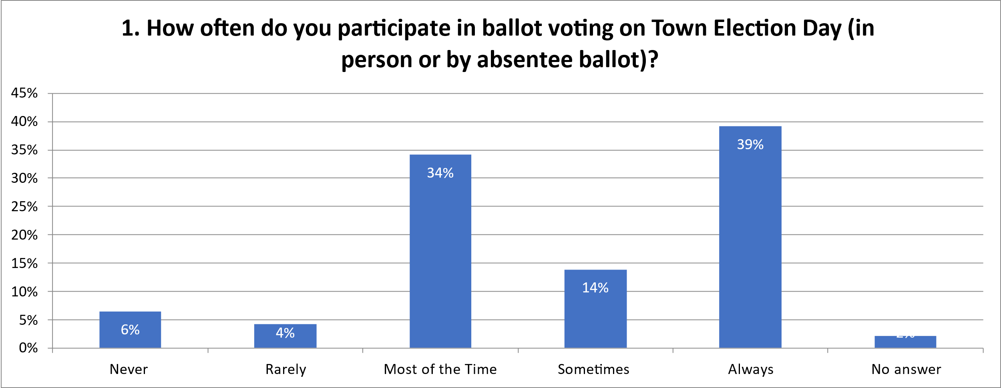

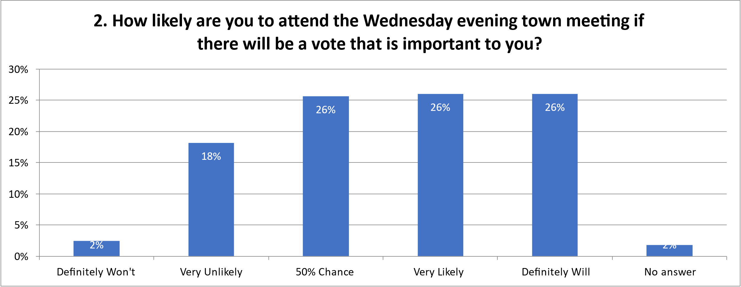

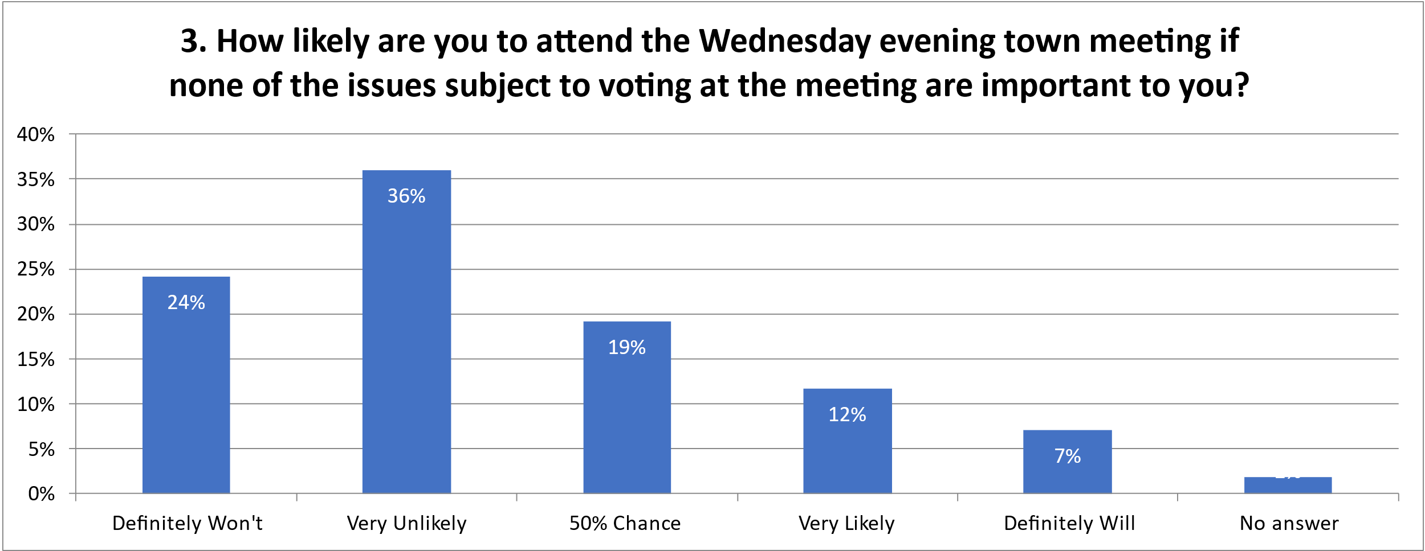

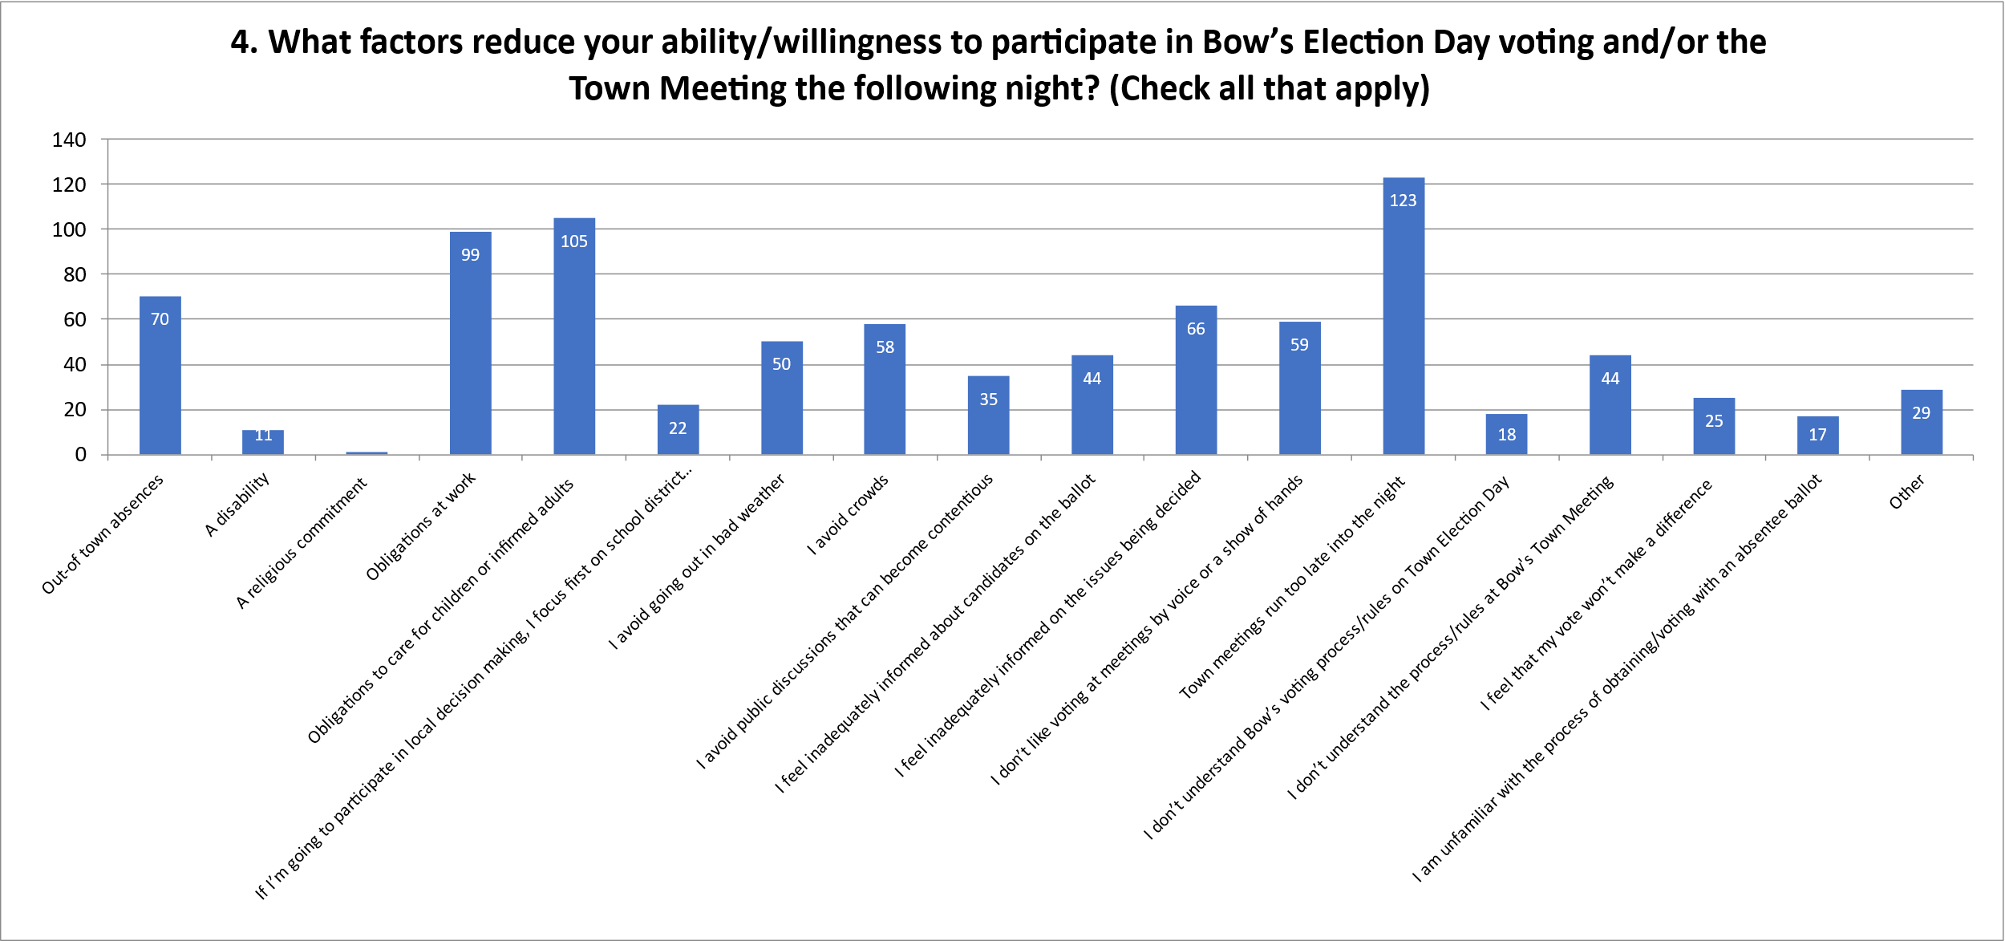

- RECOMMENDATIONS
When considering optional forms of government, the Committee reviewed the existing Town Charter, established in 1727, and agreed that after nearly 300 years it would be worthwhile for today’s citizens to consider a new Charter. Because a charter can be fashioned, within statutory limits, to provide for direct citizen decision making in identified areas, we agreed that a new charter could address many of the identified concerns that our citizens have with the Town Meeting form of government.
The process for establishing a new charter is prescribed by RSA 49-B which is the ‘Home Rules Municipal Charters’ law that governs the creation and content of town charters. It requires an initial Town vote to establish a Charter Commission whose members would be elected. The Charter Commission would be charged with developing a charter that would be presented for adoption by Town vote at a subsequent Town meeting.
To be clear, the Committee is not recommending the adoption of one specific form of government among those that are allowed under RSA 49-B, Rather, the Committee recommends that the option of a new Town Charter be presented to Bow’s citizens in the coming months, first in informational forums and presentations about all of the Town’s options for governance and then for discussion, debate and consideration at the 2023 Town meeting.
The Committee specifically recommends the Board of Selectmen establish an ad hoc committee charged with:
- Informing the citizens of Bow during 2022 about the pros and cons of the various alternative forms of governance that are available to our Town, and the role of a Charter Commission if approved at the 2023 Town Meeting. The opportunities the ad-hoc committee creates for information sharing during 2022 should include methods for participants to provide feedback and input about their perceptions’ of Bow’s needs and priorities.
- Preparing a comprehensive presentation for the 2023 Town meeting of the scope of responsibility of a Charter Commission, and that voting on whether to change to a Charter form of government could not occur before the 2024 Town Meeting and,
- Preparing and presenting a warrant article before the 2023 Town Meeting permitting those in attendance to discuss, debate and vote on whether to form a Charter Commission, following the process for establishing a new charter that is prescribed by RSA 49-B.
The Committee recommends that the ad hoc committee include:
- A Selectman
- No fewer than 5 citizens
- The Town Moderator (if willing to serve)
- The School Board Moderator (if willing to serve).
The Committee further recommends that the Select Board develop and adopt measures that improve the public’s access to information about current government affairs. For example, we encourage the Town to expand its use of electronic communications and technology, which are widely available to the Town’s citizens.

ATTACHMENT A

PROVIDED SEPARATELY

ATTACHMENT B
INVITATION TO PARTICIPATE IN THE TOWN GOVERNMENT COMMITTEE

Posted on Town of Bow Facebook page 4/19/21

At the 2021 Annual Town Meeting, residents were presented with an opportunity to vote to adopt the Special Ballot (SB2) form of government. The initiative was defeated.
After the meeting, some residents have expressed a desire to have a group come together to review all options and potential alternatives to the current town meeting form of government.
A common thread through all alternatives that have been discussed on the Bow Community Facebook page is to try and find a way to make the current process more accessible to allow more residents to participate in the decision-making process.
If you are interested in being part of the discussion and serving on a study committee, please contact the Board of Selectmen’s Office at 223-3910, or tlindquist@bownh.gov

ATTACHMENT C
SAMPLE OF SURVEY

Survey of Bow Residents - Town Governance
Hello!
We are Bow’s Town Governance Committee, volunteers who have been charged by the Bow Select Board to:
- Investigate alternatives to the current town meeting form of government
- Make sure the Town is meeting its constitutional requirement to provide adequate access to voting
- Make a formal report and recommendations to the Town’s citizens no later than the March 2022 Town Meeting
In assessing Bow residents’ needs and interests in changing the Town’s form of government, we need your help. Please complete this survey and encourage other residents to do the same. We welcome respondents from all walks of Bow life, regardless of how long they have lived here, their level of involvement in town services and activities, political views, voting status, and familiarity with town governance. We’re encouraging any and all residents who are at least 16 years of age to complete the survey.
Please note that our study pertains only to the governance of the Town of Bow and not our school district, which is governed as its own entity, separate from the Town.
Please email us with any questions about the survey:
bowgovstudycom.2021.22@gmail.com
PLEASE COMPLETE YOUR SURVEY NO LATER THAN JANUARY 18, 2022.
Thank you very much for completing this important survey. It takes five to ten minutes to complete. We value your input.
Sincerely,
The Town Governance Committee of Bow NH
Harry Judd, Chair
Angela Brennan
Susan Marcotte-Jenkins
Andrew Mattiace
Joyce Prowse

There are 17 questions in this survey.

STEP 1: CONSIDERATIONS ABOUT BOW’S CURRENT FORM OF GOVERNMENT
- Voting in Bow currently occurs in two sessions:
- BALLOT VOTING on Town Election Day, which is usually the second Tuesday in March, and
- the TOWN MEETING on the evening following Town Election Day. At the meeting voting matters are deliberated, possibly amended, and decided by voters who attend in person.
- Absentee ballots are available for ballot voting but not for town meeting votes.
- Town meeting usually occurs on Wednesday evening; the Bow School District’s annual meeting usually occurs two nights later, on Friday.

1. How often do you participate in ballot voting on Town Election Day (in person or by absentee ballot)?
Please choose only one of the following:
- Never
- Rarely
- Sometimes
- Most of the Time
- Always

2. How likely are you to attend the Wednesday evening town meeting if there will be a vote that is important to you?

Please choose only one of the following:
- Definitely Won't
- Very Unlikely
- 50% Chance
- Very Likely
- Definitely Will

3. How likely are you to attend the Wednesday evening town meeting if none of the issues subject to voting at the meeting are important to you?
Please choose only one of the following:
- Definitely Won't
- Very Unlikely
- 50% Chance
- Very Likely
- Definitely Will

4. What factors reduce your ability/willingness to participate in Bow’s Election Day voting and/or the Town Meeting the following night? (Check all that apply)
Please choose all that apply:
- Out-of town absences
- A disability
- A religious commitment
- Obligations at work
- Obligations to care for children or infirmed adults
- If I’m going to participate in local decision making, I focus first on school district matters
- I avoid going out in bad weather
- I avoid crowds
- I avoid public discussions that can become contentious
- I feel inadequately informed about candidates on the ballot
- I feel inadequately informed on the issues being decided
- I don’t like voting at meetings by voice or a show of hands
- Town meetings run too late into the night
- I don’t understand Bow’s voting process/rules on Town Election Day
- I don’t understand the process/rules at Bow's Town Meeting
- I feel that my vote won’t make a difference
- I am unfamiliar with the process of obtaining/voting with an absentee ballot
- Other: _____________________________________________

STEP 2: CONSIDERATIONS ABOUT ALTERNATIVE FORMS OF GOVERNMENT
State law permits alternatives to Bow's town meeting form of town government. For example, some types of government would transfer at least some voting decisions from the voters to elected representatives. In other forms of government, voting decisions currently made at our in-person town meetings would be made via ballot voting on Town Election Day, in voting booths or by absentee ballot.
NOTE: The next two questions refer to voting decisions that we have classified as "Various Questions of Policy". These are examples from prior years:
adopting curbside trash pickup, placing town-owned land in conservation, increasing the number of selectmen, establishing town-operated childcare programs, adopting a business development plan, and contracting with emergency response services

How important to you is HAVING YOUR OWN, DIRECT VOTE on the following matters as compared to having informed, elected representatives decide them?

Please check the appropriate response for each item: | Not at All Important | Slightly Important | Moderately Important | Very Important | Extremely Important
Changes to Land Use Policies/Rules
Major Purchases
Operating Budgets
Issuing Bonds (to finance construction projects, etc)
Various Questions of Policy

2. When the following matters are put to a popular vote, how important to you is having the option of voting on them by ABSENTEE BALLOT?
Please check the appropriate response for each item:
 | Not at All Important | Slightly Important | Moderately Important | Very Important | Extremely Important
Candidates for Town Offices
Changes to Land Use Policies/Rules
Major Purchases
Operating Budgets
Issuing Bonds (to finance construction projects, etc)
Various Questions of Policy

3. When a very lengthy ballot on Town Election Day might create long waits to vote in person, how helpful to you is seeing a sample copy of the ballot before you arrive at the polls to vote?
Please choose only one of the following:
- Worthless
- Slightly Helpful
- Moderately Helpful
- Very Helpful
- Extremely Helpful

4. How likely are you to attend at least one in-person meeting every winter for learning and deliberating about the issues being put to a town vote if the actual vote is postponed to a ballot vote on Election Day? Please choose only one of the following:
- Definitely Won't
- Very Unlikely
- 50% Chance
- Very Likely
- Definitely Will

5. How accessible to you are the following technological means for learning about town candidates and voting issues?
Please check the appropriate response for each item:
 | Not at All Accessible | Possibly | Probably | Very | Definitely Accessible
Zoom Meetings
Online, Live Webinars
Prerecorded meetings and presentations via YouTube, Facebook, etc
Town Website
Social Media
Email

6. How likely are you to view one or more online meetings, either live or prerecorded, to learn about the candidates and issues that will be on the voting ballot on Town Election Day?
Please choose only one of the following:
- Definitely Won't
- Very Unlikely
- 50% Chance
- Very Likely
- Definitely Will

7. How valuable to you are these other means of learning about candidates and voting issues?
Please choose the appropriate response for each item:
 | Worthless | Slightly Helpful | Moderately Helpful | Very Helpful | Extremely Helpful
Friends and Neighbors
Newspapers
Flyers
Canvassers
In-person gatherings
Town of Bow Newsletters

8. Most of the questions (“articles”) that are put to a vote at our current town meetings are developed by very well-informed members of the Select Board and Budget Committee, who we elect. At Bow’s current town meetings, voters can amend the articles before their final vote. How important is this chance for voters to amend the articles?

Please choose only one of the following:
- Not at All Important
- Slightly Important
- Moderately Important
- Very Important
- Extremely Important

9. Mark below conditions that would significantly increase the likelihood of your voting and/or participating in voting-related activities.
Please choose all that apply:
- Provide rides to and from my home
- Provide childcare during meetings
- Guarantee that an evening meeting will end by 10 pm
- Schedule voting-related meetings on a Saturday morning
- Schedule voting-related meetings on a Sunday evening
- Postpone voting at the polls when there is a bad storm
- Postpone voting-related meetings when there is a bad storm
- Postpone voting to the Spring
- Increase opportunities prior to voting to learn about the candidates and issues being put to a vote
- Minimize the time it takes to vote
- Provide sample ballots before I vote
- Allow absentee ballot voting regardless of reason for absence
- Mail a ballot to every registered voter
- Schedule Town Meetings outside the week of the annual School District meeting
- Provide online voter registrations
- Other: _________________________________________________
FINALLY, A LITTLE INFORMATION ABOUT YOU

1. Do you currently reside in Bow?
Please choose only one of the following:
- Yes
- No

2. For how many years have you lived in Bow?

Please choose only one of the following:
- 0 - 5 years
- 6 - 10 years
- 11 - 15 years
- 16 - 20 years
- 21 - 25 years
- 26 - 30 years
- 31 or more years

3. Are you currently registered to vote in Bow?
Please choose only one of the following:
- Yes
- No

4. How old are you?
Please choose only one of the following:
- 16 - 17 yrs
- 18 - 29
- 30 - 39
- 40 - 49
- 50 - 59
- 60 - 69
- 70 - 79
- 80 or over
Thank you for completing this survey.
To submit your survey, please return the survey in a sealed envelope labeled ATTN: TOWN GOVERNANCE COMMITTEE to the Town Municipal Building no later than Tuesday January 18.
If you need your survey picked up, arrangements can be made by emailing bowgovstudycom.2021.22@gmail.com

ATTCHMENT D
SURVEY DESIGN AND DISTRIBUTION

TOWN GOVERNANCE COMMITTEE’S JANUARY 2022 SURVEY OF BOW RESIDENTS
Survey Design
A member of the Town Governance Committee did some research about basic survey design, which was a help in formulating the questions and the survey’s format. The 17 questions in the survey focused on features of various forms of government. The choice of responses to most of the questions were on scales of importance, likelihood, frequency, etc. Some were multiple-choice questions. There were no open-ended questions largely because we didn’t have the resources to collect and process wide-ranging comments. However, two multiple-choice questions provided an open-text “Other” option in which several respondents made comments.
We hope a follow-up educational public forum or series in 2022 will promote the kind of dialog that our survey did not solicit.

Respondents’ Demographic Information
The only demographic information that was collected about the survey participants was whether they are Bow residents, the amount of time they have lived in Bow, whether they are registered to vote, and their age. We were asked at least couple of times about our decision to invite 16- and 17-year old residents to participate in the survey, even though they are not old enough to vote.

The Committee wanted to hear from a cross section of Bow residents that represents the entire town. Any decision the town makes about its form of government will likely have an impact on every resident regardless of their age, political views, voter registration status, income level, etc. Bow’s Selectmen asked our committee to address “adequate access to voting”. Giving soon-to-be voters the chance to participate in our survey would, we hoped, engage them in town matters and encourage them to vote when they reach 18 years of age. Unfortunately, this discussion about our inviting 16- and 17-year old residents to participate in the survey is moot; no one in that age group participated in the survey.

Electronic vs Paper Survey
There were several advantages of an electronic survey over a paper survey, including cost and time efficiencies and addressing security concerns (see below). We avoided expenses by avoiding the need to transfer responses on a paper survey into an electronic data base for reporting results.

We developed a paper version of the survey for residents who do not use electronic communication; however, the challenges of identifying these residents plus printing, distributing and collecting paper surveys ultimately only confirmed our decision to make the survey electronic.

Security and LimeSurvey
As we learned about survey management, we became very mindful of the ways in which surveys are frequently “gamed” especially by what is called “multiple participation” whereby individuals submit multiple surveys. As we selected the survey software we would use, we factored in the availability of security measures as well as cost. We chose LimeSurvey mainly because of its low cost and the variety of features it offered to manage our survey’s distribution and security. LimeSurvey gave us the option of limiting responses from individual computer devices (one survey per device) or from individual email addresses (one survey per address). We chose the latter.

Distribution
The Committee opted not to merge email address lists from various Bow organizations into our survey database. Rather, we tried to broadly broadcast the public link to our survey. It was posted on the Town website and social media and in an electronic communication managed by the Bow school district. We also posted in various public places a paper flyer with a QR code to our survey.

Email addresses and Anonymity
We received some inquiries about our use of email addresses, which we used to prevent multiple participation by individual respondents. (When a survey participant clicked on the public link to the survey, they were asked for an email address. Our software then emailed them a unique, coded link to the survey that allowed one use of the survey for each email address.)

With every mention about the survey, we explained that the surveys were anonymous: LimeSurvey saved the addresses in a data base that was separate from the survey responses. There was no way anyone could match an email address to its owner’s responses to the survey. The data base is encrypted by LimeSurvey. Moreover, our introduction to the survey explained that the email addresses will not be used for any purpose other than the survey.
The tradeoff for securing our survey from misuse was the extra step created in registering to complete the survey by providing an email address. Among more than 300 survey registrations, there were about 40 survey registrations that did not result in a completed survey. Likely explanations include invalid email addresses, email messages that landed in and were not retrieved from people’s email junk folders, and attempts to use an email address that had already been used for the survey by someone else.

ATTACHMENT E
COMMITTEE MINUTES

June 1, 2021
First Meeting of Town Governance Committee
Town of Bow Municipal Building, Meeting Room C
Meeting called to order 7:10pm

Present:
Harry Judd
Andrew Mattiace
Joyce Prowse
Margaret Byrnes
Angela Brennan
Sue Marcotte-Jenkins
Introductions
Committee voted for Chair, Vice Chair, Secretary
- Chair - Harry Judd
- Vice Chair - Margaret Byrnes
- Secretary - Angela Brennan
Reading materials distributed to members:
- Committee charter as outlined by Town Board of Selectmen
- NH Town Government information packet provided by Tonia Lindquist
- 2001 Report of The Town of Bow Alternative Forms of Government Committee

Schedule discussed:
- Committee will schedule periodic meetings as needed
- Next meeting scheduled for June 16, 2021
- Meetings expected to be one hour
- No meetings will be held in August
- Consensus that scheduling meetings this summer may prove difficult for all members to attend in person. Zoom may be considered if pending legislation passes after Governor Sununu’s emergency order, which authorizes remote meetings, expires in the coming days.
Committee agrees to publish official agenda every meeting henceforth
- Agenda items must be submitted no later than 5 calendar days prior to next meeting
- Deadline for agenda item requests for 6/16/21 meeting is Friday, June 11, 2021
Andrew Mattiace moved adjournment, seconded by Margaret Byrnes, and approved by unanimous vote of the Committee at 8:15 pm.

********************/
October 7, 2021
Town Governance Committee Meeting
Town of Bow Municipal Building, Meeting Room

Meeting called to order 7:05pm
Present:
Harry Judd (Chair)
Andrew Mattiace
Joyce Prowse
Angela Brennan
Sue Marcotte-Jenkins (via Zoom)
Chair Harry Judd opened discussion highlighting that there are multiple governance options for our town to consider beyond our current town meeting format and SB2.
Andrew Mattiace studied towns with varying forms of governance and presented a slideshow to inform the committee about the options available to New Hampshire communities in cities and towns.
Sue Marcotte-Jenkins suggested seeking more information about representative town meeting.
Joyce Prowse addressed the need to have a form of governing that does not require citizens of Bow to attend a lengthy meeting that requires physical presence to participate in voting on critical town issues.
Committee members will each prepare a list of commonly expressed concerns and challenges facing citizens of Bow that may hinder their participation in town meeting.
The committee is interested in seeking additional information about writing a town charter that might address issues commonly expressed about town meeting and SB2.
The committee resolves to create a questionnaire to send out to citizens of Bow to help identify needs, values, and concerns about town governance.

Future meetings will be scheduled for Wednesdays at 7:00pm.
Next meeting will be October 20, 2021 at Bow Municipal Building.
November meetings are tentatively scheduled for November 3 and 17, 2021.

Andrew Mattiace motioned to adjourn the meeting, Sue Marcotte-Jenkins seconded, committee approved unanimously and meeting was adjourned at 8:10pm.

**********/
October 20, 2021
Town Governance Committee Meeting
Bow Municipal Building Meeting Room

Meeting called to order 7:00pm
Present:
Harry Judd (Chair)
Andrew Mattiace
Joyce Prowse
Angela Brennan
Sue Marcotte-Jenkins (via Zoom)

Chair Harry Judd opened the meeting with an overview of the outlined agenda and a notice that minutes from October 7, 2021 meeting will be printed and reviewed at the next meeting.

Andrew Mattiace gave a full presentation of the New Hampshire Forms of Government slideshow that he has been working on. Andrew previously provided a brief overview to the committee last meeting.
Town of Bow currently operates with an Open Town Meeting form of government where the Select Board is the Executive and the voters are the Legislative body.
Other options available for consideration include:
Representative Town Meeting - town is divided into districts, elected representatives for each district attend the town meeting and act as the legislative body. Currently there are no towns in New Hampshire operating with this form of governance.
“SB2” Ballot Voting - Deliberative session and separate ballot voting days to vote on items outlined during deliberative session.
Customized Governance - Parameters for this form of government are established in a Town Charter to meet the specific needs of the town.
Town Council - Established by a Town Charter that gives power to an elected body of 15 members to act as both the Executive and Legislative bodies on behalf of the town’s citizens. This is essentially a town version of a City Council. City of Concord governs by City Council.
Town Council and Ballot Voting - Established by a Town Charter that gives executive power to an elected body (as above) and allows the townspeople to vote on some specific items by ballot.
Town Council and Budget Town Meeting - Established by a Town Charter that gives power to an elected body (as above) and townspeople vote only on budgetary items in a town meeting format.

Angela Brennan suggested that the committee consider Town of Bow’s future population growth when making it’s ultimate recommendation. Compared to populations of other towns operating under Open Town Meeting governance, Town of Bow’s population is at the high end of the spectrum.

Joyce Prowse presented information about the role, duties, and goals of the Town Manager position.

Harry Judd distributed the Moderator’s Rules of Procedures document for committee members to review.

Committee members will prepare notes and/or questions to work towards drafting a survey to receive input from the community.

Next meeting is scheduled for Wednesday, November 3, 2021 at 7:00 pm.

Joyce Prowse motioned to adjourn the meeting, Harry Judd seconded, committee unanimously approved and meeting was adjourned at 8:27pm.
************/
November 17, 2021
Town Governance Committee Meeting
Bow Municipal Building Meeting Room
Present:
Harry Judd
Andrew Mattiace
Joyce Prowse
Sue Marcotte-Jenkins
Angela Brennan

With the entire committee present at 7:00pm, the committee photo was kindly taken by Eric Anderson.

Chair Harry Judd officially opened the meeting at 7:10pm.

Meeting minutes from October 7, 2021 were distributed, reviewed and a motion to approve the minutes was made by Sue Marcotte-Jenkins, seconded by Joyce Prowse, and unanimously approved.
Meeting minutes from October 21, 2021 were distributed, reviewed, and a motion to approve the minutes was made by Andrew Mattiace, seconded by Joyce Prowse, and unanimously approved.

Angela Brennan asked for clarification on what the timeframe would be if this committee decided to recommend a charter commission, given that most alternate forms of town government would require one.
Harry Judd and Sue Marcotte-Jenkins provided an estimated timeline:
- 2022 Town Meeting would allow voters a chance to vote to establish Charter Commission
- 2023 Town Meeting ballot election would allow voters to vote for individuals to serve as Charter Commissioners and they would begin to formulate a new town of Bow Charter.
- 2024 - The Commissioners would present the Charter to the town voters to consider adopting the Charter.

The focus of the remainder of the meeting was to review the survey drafted by Sue Marcotte-Jenkins. This survey will allow citizens of Bow to contribute to this committee’s understanding of the needs of our townspeople. Andrew Mattiace presented the survey and made adjustments to the document as needed. The committee went line by line to review the survey.

In order to work expeditiously to get the survey out to the citizens of Bow as soon as possible, Sue Marcotte-Jenkins and Andrew Mattiace will work together on Monday, November 22 to finish editing.
Committee members will submit any suggestions that come up over the weekend to Sue and Andrew by Monday morning.

The next meeting is scheduled for December 7, 2021 at 7:00pm.

A motion to adjourn was made by Joyce Prowse at 8:30pm, seconded by Sue, and unanimously approved.
Meeting adjourned at 8:30pm.

*************/
December 7, 2021

Zoom discussion

Present:
Harry Judd
Andrew Mattiace
Sue Marcotte-Jenkins
Angela Brennan

Due to illness, the meeting was switched from in person to Zoom.

Upon connecting to the Zoom meeting, the consensus was to reschedule the meeting to December 15, 2021.

The committee will plan to meet in person on December 15, 2021 at 7:00pm.

December 15, 2021
Town Governance Committee Meeting
Bow Municipal Building Meeting Room
Present:
Harry Judd
Joyce Prowse
Sue Marcotte-Jenkins
Angela Brennan

Absent:
Andrew Mattiace

Chair Harry Judd opened the meeting at 7:00pm.
The minutes from November 17, 2021 were reviewed and Joyce Prowse made a motion to approve, Sue Marcotte-Jenkins seconded, and the minutes were unanimously approved.

Discussion began about the committee’s timetable for completion. This committee is charged with providing a full and complete report to the Select Board and the town. Harry Judd sees two options for the committee to consider:
- Finish all work by February 1 so that if this committee delivers a recommendation that requires a town vote at the 2022 Town Meeting, the potentially proposed question could meet the deadline.
- Ask the Select Board for an extension, issue the survey to the town after the holidays, in early to mid-January, delay issuing the full report, and possibly seek additional committee members to continue working beyond the Town Meeting date.

The committee agreed that issuing a survey to citizens of Bow to establish hard data during the holiday season would likely fail to deliver a representative pool of respondents.

Angela Brennan asked for consideration of an option that is a combination of Harry’s two options, which would allow this committee to deliver a partial report with some recommendations in time for town meeting, particularly if establishing a charter commission is proposed by this committee, and seek an extension from the Select Board to continue working on research and engage more with town citizens since we have been limited by the Covid-19 pandemic and scheduling.

Harry Judd agreed that an extension would allow this committee to put together a thorough, educational packet designed for the public to be informed of this committee’s work, conclusions, and recommendations.

Joyce Prowse expressed a concern about uninformed voters and agreed that our communication with voters is important.

Sue Marcotte-Jenkins agreed that continuing on beyond the Town Meeting deadline would allow the committee to better educate voters on our findings and recommendations, especially if the committee recommends and the voters decide to establish a charter commission.

The committee resolved to charge ahead, put forth a presentation, with findings and recommendations as they stand at the time, to the Select Board and citizens that meets Town Meeting deadlines (presumably February 1, if the committee recommendations require a vote at Town Meeting), and make a formal request to the Select Board asking for an extension to allow the committee to continue working beyond the submission of the presentation.

Harry Judd stressed the need for a solid presentation that includes information about the forms of town governance that were considered by this committee.

Further discussion about the presentation to the town will be put on the agenda for an upcoming meeting.

The committee reviewed the latest version of the survey, approved it with some discussion and agreed to permit Sue Marcotte-Jenkins to make minor changes to wording.

Sue Marcotte-Jenkins suggested putting the survey out to a sample group of about 25 people to test and give feedback on the following areas:
- Length of survey and time to complete
- Ease of understanding and identify ambiguity or related issues
- Impression of or detection of unforeseen bias
- General comments, observations, questions, concerns

The sample version with a cover letter informing the respondents of the purpose of this survey is expected to be ready by the next meeting. Each committee member will take responsibility for distributing the survey to approximately 5 people to reach our sample group goal of 25 respondents. This should allow the committee to receive feedback and make appropriate adjustments, if needed, before the survey is sent out to the general public in January.

Next meeting scheduled for December 22, 2021 at 5:00pm.

Sue Marcotte-Jenkins made a motion to adjourn, Joyce Prowse promptly seconded and the meeting was adjourned at 8:20pm.
***************/
December 22, 2021
Town Governance Committee Meeting
Bow Municipal Building Meeting Room

Present:
Harry Judd
Andrew Mattiace
Angela Brennan
Sue Marcotte-Jenkins

Absent:
Joyce Prowse

Chair Harry Judd opened the meeting at 5:00pm and the committee agreed to keep this meeting brief.
The minutes from the December 15 meeting were distributed and reviewed. The committee decided to hold off on approving the minutes until the next meeting when all members are expected to be present.

Committee members confirmed that they received the email from Angela Brennan with the Google Form version of the survey. Andrew Mattiace tested the Google Form survey using his cell phone and confirmed that it is easily accessible using a cell phone.

The committee agreed to conduct beta testing of the Google Form version of the survey by sending it out to five people, as previously discussed, to seek feedback.

Harry Judd will reach out to the Interact club at Bow High School to see if any juniors and seniors in the club would be willing to test the survey and give feedback.

Sue Marcotte-Jenkins has been researching surveying companies that offer a broader range of data analysis and security features beyond those offered by Google Forms. Sue will continue to review the options available with Lime Survey to see if that company better meets this committee's needs.

Angela Brennan will work to make minor adjustments on the Google Form survey.

The committee will next meet on Wednesday, January 5, 2022 at 6:00pm.

Sue Marcotte-Jenkins moved to adjourn, Andrew Mattiace seconded and the meeting was adjourned at 5:28pm.

*****************/
January 5, 2022
Town Governance Committee
Microsoft Teams Meeting

Present:
Harry Judd
Angela Brennan
Andrew Mattiace
Sue Marcotte-Jenkins
Joyce Prowse

Chair Harry Judd opened the Microsoft Teams meeting at 7:00pm.
The committee discussed survey feedback from the test group. Survey testers indicated a need to shorten the instruction page and reported that the estimated time to complete the survey was between 5-10 minutes.Overall survey testers found it easy to follow and easy to complete.

The committee agreed that putting the survey out as soon as possible is necessary and developed a plan to reach out to the Town, Baker Free Library, and School Superintendent to request sharing of the survey.

Minor edits to finalize the survey will be completed and the survey will be made public on Sunday, January 9, 2022.

The committee agreed to close the survey on Tuesday, January 18, 2022 to give Bow citizens more than a week to access the survey while allowing the committee time to review the data at the next meeting on Wednesday, January 19.

Contact information will be provided with every posting of the survey to make sure respondents can reach out to the committee if they have questions or need assistance.

Joyce Prowse moved to adjourn, Sue Marcotte-Jenkins seconded, and the meeting was adjourned at 7:55pm.

******************/
January 19, 2022
Town Governance Committee
Bow Municipal Building

Present:
Harry Judd
Andrew Mattiace
Angela Brennan
Sue Marcotte-Jenkins (via Microsoft Teams)
Joyce Prowse (arrived 6:55pm)

Chair Harry Judd opened the meeting at 6:00pm.
Meeting minutes from December 15, December 22, and January 5 were reviewed. Andrew Mattiace motioned to approve the minutes for each date, Sue Marcotte-Jenkins seconded, and the minutes of December 15, December 22, and January 5 were unanimously approved.

The committee’s survey was issued to the town citizens for participation between January 9 and January 18, 2022. The results were made available to committee members on January 19, 2022 through the LimeSurvey software program.

Survey results were reviewed at length. The committee will provide a written summary of the results as well as graphs with the raw data in the report delivered to the Board of Selectmen on January 25, 2022.

The committee worked on the outline for the report and divided up the drafting of each section to members. Members will work on drafting sections and compiling data into the report over the weekend.

At 8:30pm, Joyce Prowse motioned to adjourn, Sue Marcotte-Jenkins promptly seconded, the committee unanimously agreed and the meeting was adjourned.
ATTACHMENT F
SUMMARY – ALTERNATIVE FORMS OF TOWN GOVERNMENT

